
Business Intelligence Dashboard for Smart City Traffic Pattern Analysis

Submitted in partial fulfillment of the requirements for the award of the degree of
Master of Computer Application (MCA)
By
Student Name: Priyanshu Chand
University Id: O24MCA112104
Under the guidance of
Mentor Name: Suruchi Gupta

Certificate
Copy to the certificate received from Qollabb to be pasted here.

Declaration
I, Priyanshu Chand, hereby solemnly declare that the project report titled " Business Intelligence Dashboard for Smart City Traffic Pattern Analysis " submitted in partial fulfillment of the requirements for the award of the degree of Master of Computer Application (MCA) is my original work.
I further declare that:
- This project has been carried out by me during the academic year 2025-2026 under the supervision of Suruchi Gupta.
- The work has not been submitted previously to any other university, institution, or examination body for the award of any degree, diploma, or certification.
- All sources of information used in this report have been duly acknowledged and referenced in accordance with academic ethics and plagiarism norms.
- The data presented in this report is authentic to the best of my knowledge and has not been fabricated or manipulated.
- I understand that if any part of this declaration is found to be false, my project may be rejected and disciplinary action may be taken as per institutional rules.
Place: Khatima, Uttrakhand
Date: ____________________
Student Signature:
Student Name: Priyanshu Chand
University Id: O24MCA112104

Acknowledgement

I would like to express my sincere gratitude to my guide/mentor, Ms. Suruchi Gupta, for her valuable guidance, support, and encouragement throughout the development of this project. Her insights and suggestions helped me complete this work successfully.

I would also like to thank the faculty members of the Centre for Distance and Online Education, Chandigarh University, for providing the necessary academic guidance and learning resources during my course of study.

I extend my appreciation to Qollabb and the associated organization for providing the opportunity, resources, and support required for the successful completion of this project.

Finally, I would like to thank everyone who directly or indirectly contributed to the completion of this project.

Abstract / Executive Summary (150–250 words)
- Topic of the study
- Objective
- System Analysis
- System Design
- System Implementation
- Testing
- Future Scope

Table of Contents
(Use MS Word → References → Table of Contents to auto-generate)
List of Figures

List of Tables

List of Abbreviations

Abstract
(150–250 words)
Write content here...
- Topic of the study
- Objective
- System Analysis
- System Design
- System Implementation
- Testing
- Future Scope

Chapter 1: Introduction
(MCA 5 pages
Write content here...
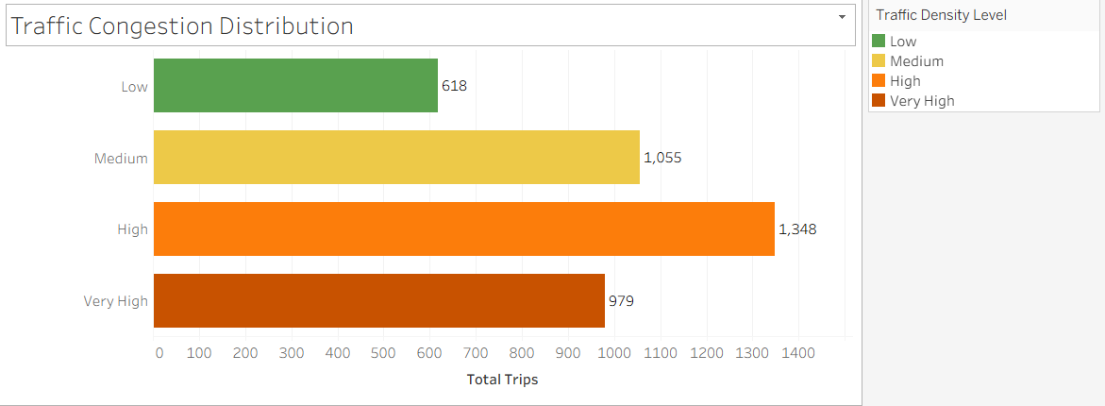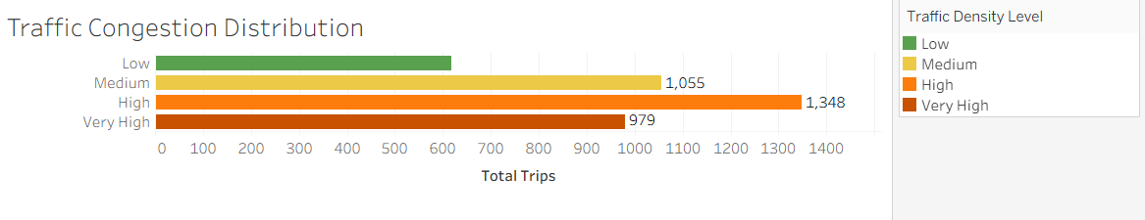

Chapter 2: System Study
(MCA/MSc(DS) min 8 pages | BCA min 5 pages)
Write content here...

Chapter 3: System Analysis
(MCA/MSc(DS) min 8 pages | BCA min 6 pages)
Write content here...

Chapter 4: System Design
(MCA/MSc(DS) min 10 pages | BCA min 8 pages)
Write content here...

Chapter 5: System Implémentation
(MCA/MSc(DS) min 12 pages | BCA min 8 pages)
Write content here...

Chapter 6: Testing
(MCA/MSc(DS) min 6 pages| BCA min 4 pages)
Write content here...

Chapter 7: Results & Discussion
(MCA/MSc(DS) min 4 pages| BCA min 3 pages)
Write content here...

Chapter 8: Conclusion & Future Scope
(MCA/MSc(DS) min 3 pages | BCA min 2 pages)
Write content here...

Chapter 9: References
(MCA/MSc(DS) 20+ sources | BCA 10+ sources)
Write content here...

Chapter 10: Appendices
(Source code, DB, manual)
Write content here...

